Bangladesh Tariff:

<https://www.bangladeshtradeportal.gov.bd/index.php?r=tradeInfo>

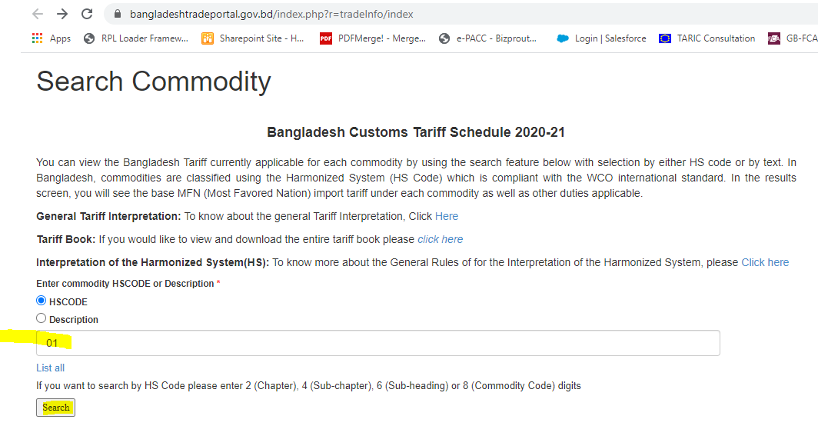

1. In search box provide 2-digit chapter number and search.

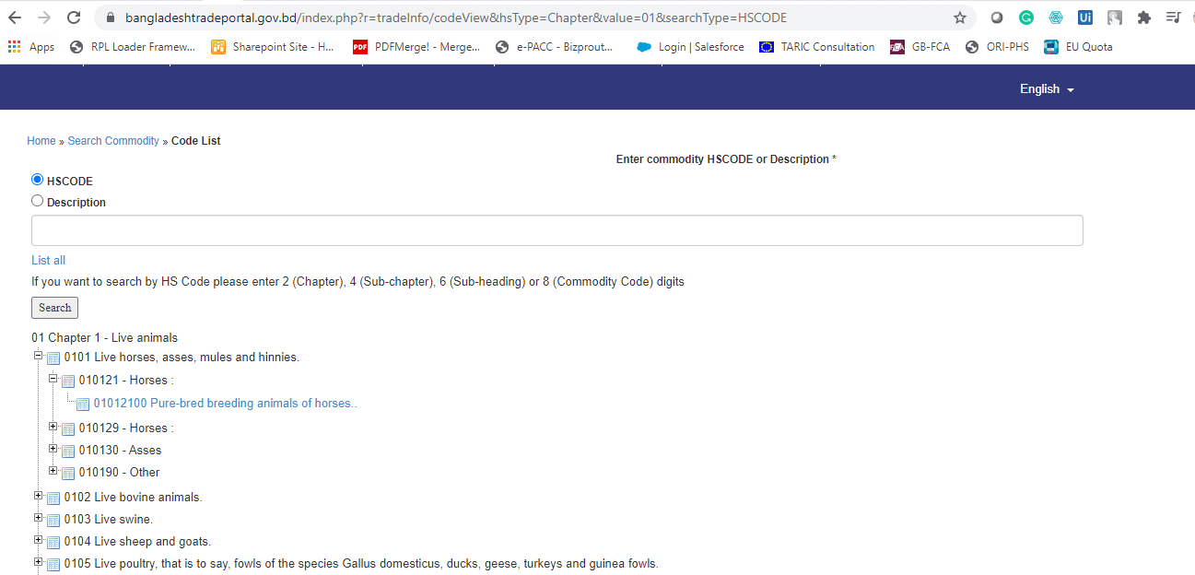

1. Expand each header level as showed above, Click on hyperlinked final digit HS number

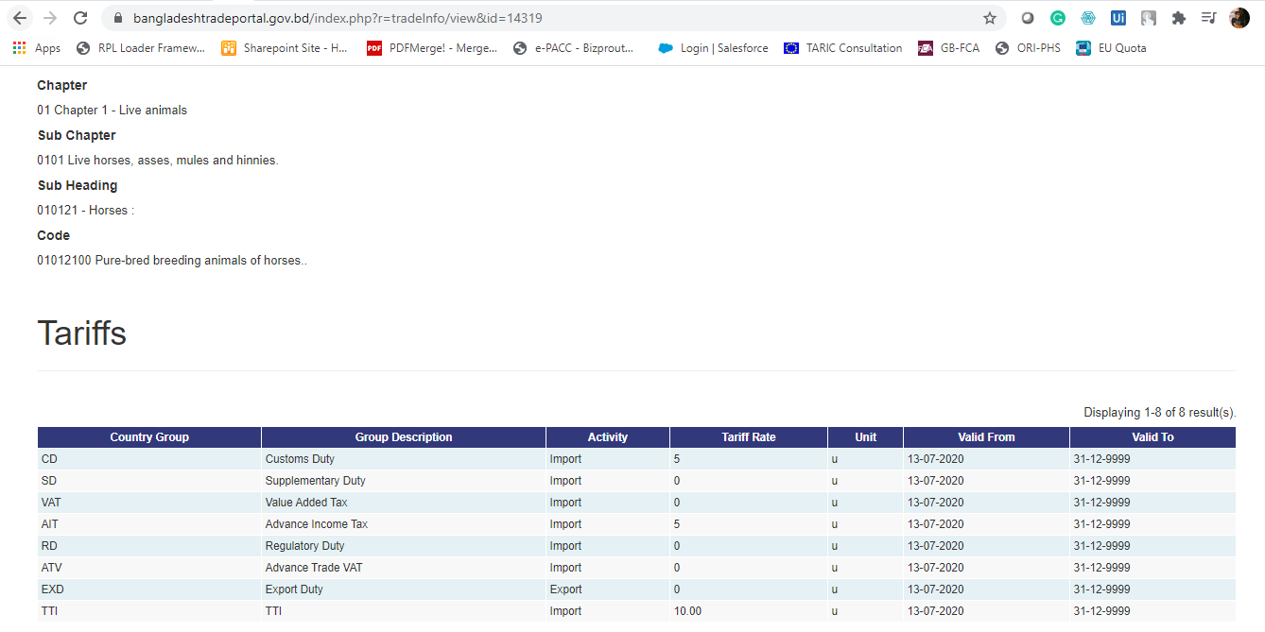

1. Please provide all information provided in above page on excel.